Use case analysis of sensors 57, 44 and 16

Subject: analysis Groenestraat

Data analysis made by: Msc. Zoi Katsamani, Radboud University, Institute for Management Research.

Assignment supervised by: dr.ir. Linda Carton, Radboud University, Institute for Management Research.

Date: 31-10-2016.

Including sensor stations: s57, s44, s16

Disclaimer:

During this use case analysis, in the meantime, the calibration process of sensors relative to national measurement stations is still in execution in this period, executed on the sensor-data of sensors s12 and s14, executed by data scientist Pieter Marsman.

The stations s44 and s16 have some (connection) disturbances during this period. Therefore some data gaps are noticed.

Short description of setup of this use case analysis
By this use case analysis we would like to notice the differences and similarities of the sensors that are located at the same area.
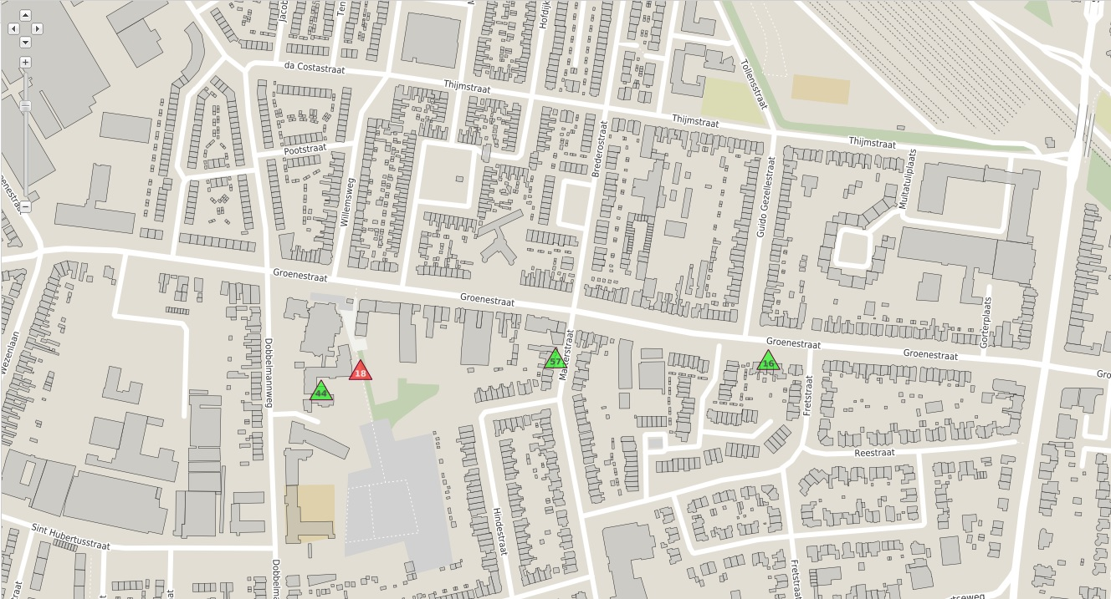
S44
S57
S16
GROENESTRAAT
Figure 1. Location of sensors 44, 57 and 16.
Furthermore, this analysis will help us have a sense about the accuracy of sensors data. For instance, we are expecting all sensors to give quite similar values of the temperature.
Therefore, we decided to check those sensors “behavior” during ten days in July (17/7-27/7 - Vierdaagse festival is included) and during ten days in September (6/9-16/9 - Heatwave is included).

Analysis 1a: Emission Carbon Dioxide (CO2)

The first graph provides information about the carbon dioxide levels during the days 17th to 27th July.
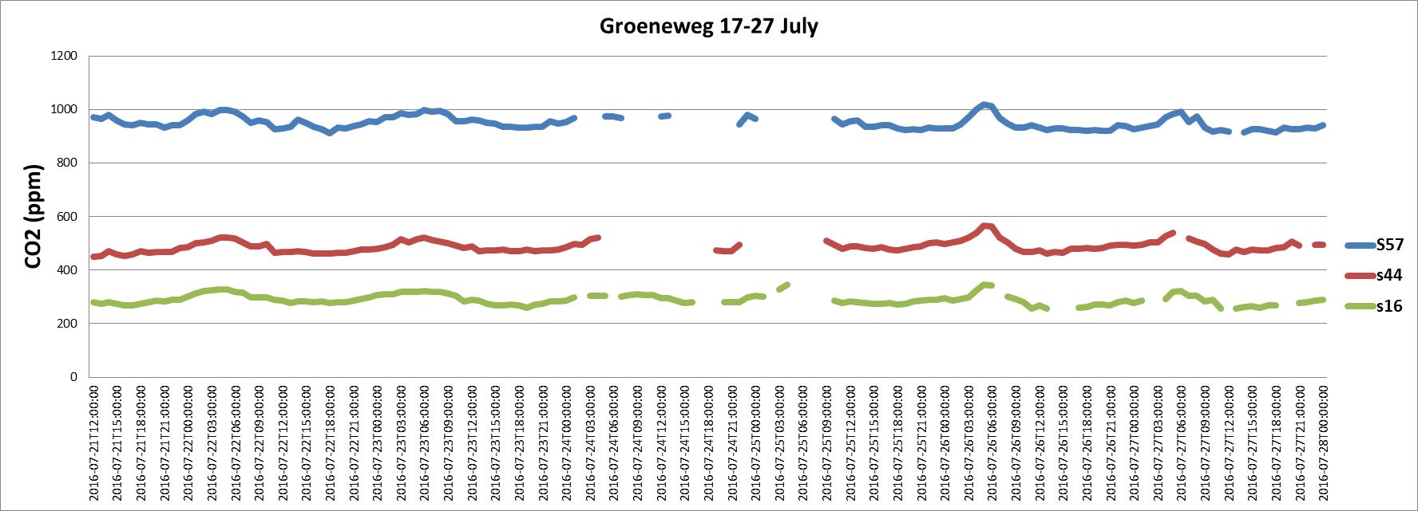
Groenestraat
Figure 2. CO2 levels through days 17/7/2016 – 27/7/2016 (sensors 57, 44 and 16).
It is obvious from the graph that these three sensors give quite different values of CO2. S57 gives the highest values, while s16 gives the lowest ones. A remarkable thing is that are not noticed big fluctuations at the values of each sensor. Furthermore, all the sensors seem to follow the same pattern during the days. For example, peak points are noticed the same dates and times.
The graph below provides information about the carbon dioxide levels during the days 6th to 16th September.
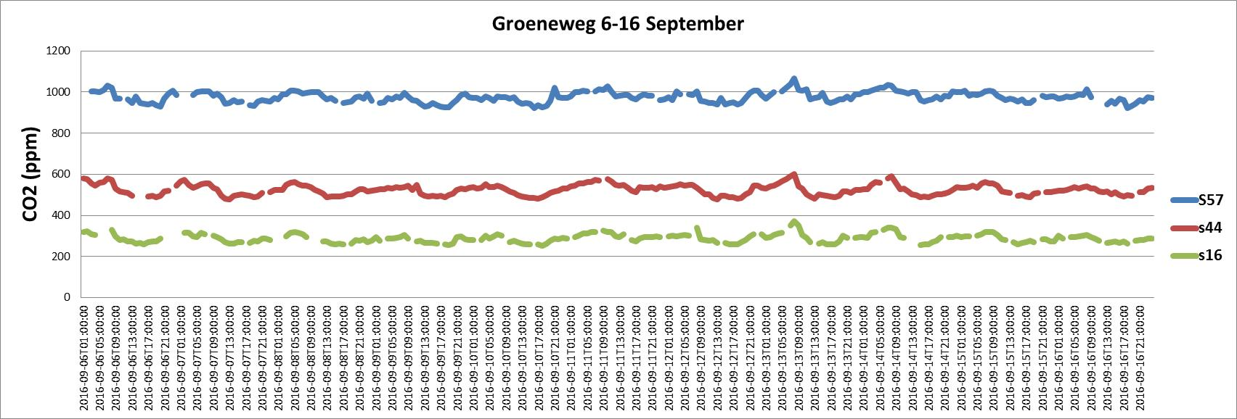
Groenestraat
Figure 3. CO2 levels through days 6/9/2016 – 16/9/2016 (sensors 57, 44 and 16).
It is clear from the graph that these three sensors give again quite different values of CO2. Although, all sensors follow the same pattern and their values have small fluctuations during these days.
Comparing these two graphs of Carbon Dioxide, we notice that each sensor gives almost the same values of CO2 at these two periods: S57 gives values around 980ppm, s44 around 490ppm and s16 around 300ppm. To sum up, the values of s44 are almost the half of the values of s57 and the values of s16 are almost the one third of the values of s57 and this seems to be stable phenomenon.

Analysis 1b: Emission Temperature

The graph below gives data about the temperature during the days 6-16 September. Sensor 16 did not give data about the temperature for that period of time.

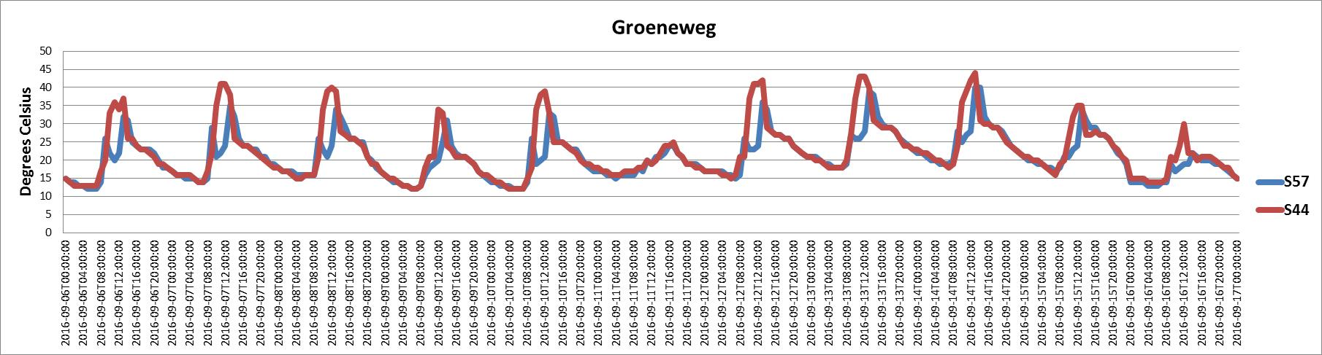
Groenestraat
Figure 4. Temperature levels through days 6/9/2016 – 16/9/2016 (sensors 57 and 44).
It is clear from the graph that both sensors give similar data about the temperature. This fact allow us to be optimistic about the accuracy of the data provided. A thing that also stands out is that during a day, the temperature changes from 8 degrees Celsius to 13 degrees Celsius, on average.
Concerning the data of July, only sensor 57 provide enough data about this period of time. Sensor 44 gives scant data, while sensor 16 does not give at all. Consequently we do not illustrate the values of July. However, the graph of September is quite enough to prove the accuracy of the data provided from sensors 57 and 44 about temperature.

Analysis 1c: Emission Noise

This graph provides information about the noise levels during the ten days of July.
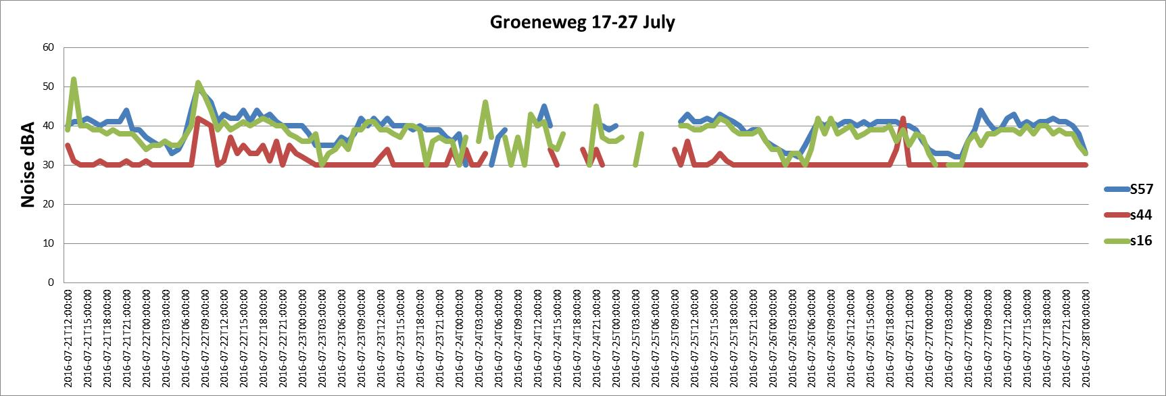
Groenestraat
Figure 5. Noise levels through days 17/7/2016 – 27/7/2016 (sensors 57, 44 and 16).
It is obvious from the graph that s57 and s16 presents quite similar data of noise. S44 gives the lowest values of noise. This is maybe related with the fact that s44 is located in the back yard of the building, while the other two sensors are placed on the street side. Some peak points are noticed during 22/7/2016 from 8:00 to 10:00 and 26/9/2016 at 20:00.
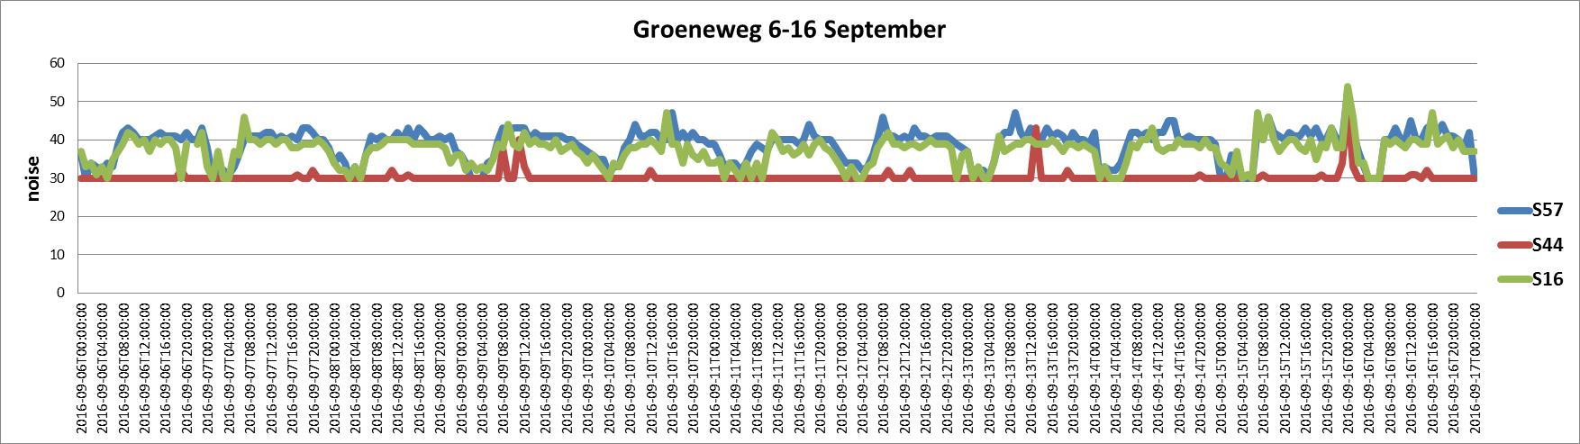
Groenestraat
Figure 6. Noise levels through days 6/9/2016 – 16/9/2016 (sensors 57, 44 and 16).
A thing that stands out most from the graph is that S44 gives the lowest values of noise. An another remarkable thing is that sensors 57 and 16 give again quite similar values of noise. Finally, three peak points are noticed for sensor 44: 9/9/2016 at 11:00, 13/9/2016 at 13:00 and 16/9/2016 at 00:00.
Comparing with these two periods of time, we conclude that s44 is the most quiet sensor, while s57 and s16 give similar data about noise. Furthermore, especially during the ten days of September, similar patterns are noticed for sensors 57 and 16.
Consequently, we considered that it would be helpful to have an overview of the noise levels for the whole month of September:
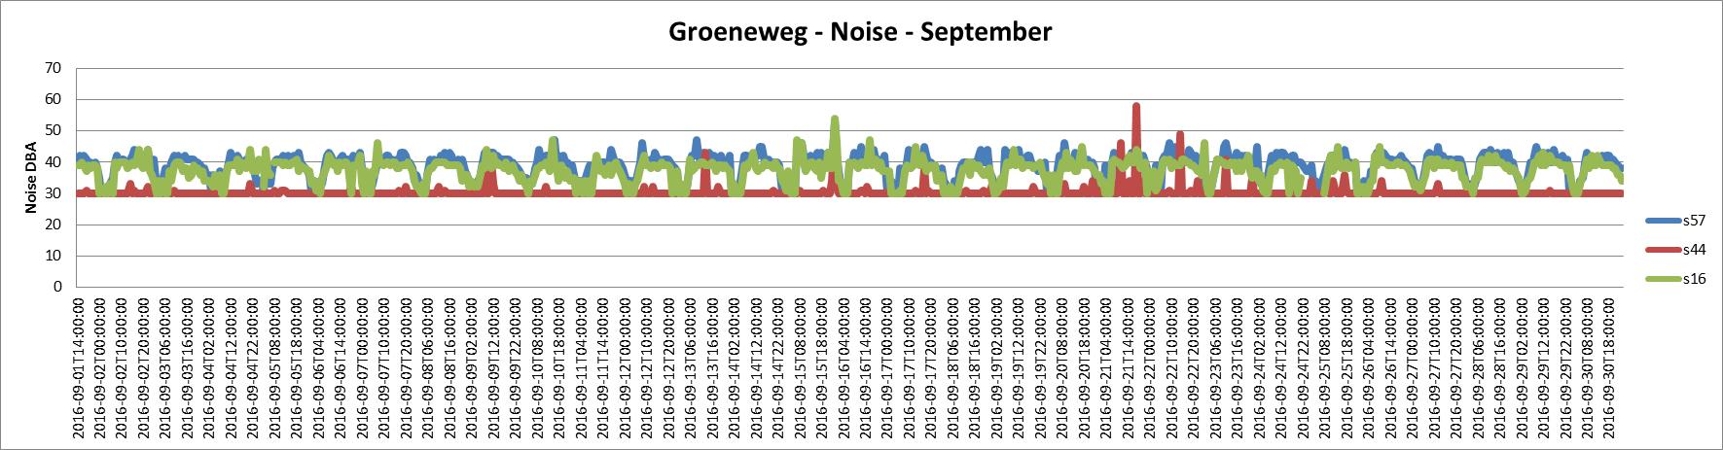
Groenestraat
Figure 7. Noise levels of sensors 57, 44 and 16 during September.

The graph above confirms our outcome that sensor 44 is the most quiet sensor. In addition, we notice that we have similar patterns during the whole month for sensors 57 and 16. If we relate these noise patterns with the traffic, then we are able to see “similar Traffic Patterns”!

Conclusions

Carbon Dioxide (CO2) emissions during 17-27 July and 9-16 September:
From these analyses on the indicative data of the smart emission sensors, it seems that CO2 is a stable gas, as the values were quite similar for both periods for each sensor. Furthermore, temperature does not seem to affect to the levels of this gas, because the heatwave in September did not change the values significantly.
Temperature emissions during the days 6-16 September:
Sensors 57 and 44 provide us with quite similar data about the temperature. That confirm the accuracy of the data of these two sensors.
Noise pattern during 17-27 July and 9-16 September:
The data that are provided for these three sensors that are located close to Groenestraat, allow us to see similar traffic patterns during these days and during the whole month of September.

---
Annex 1: Map with sensors and sensor numbers.
Annex 2: Excel file with analysis data. (Excel document, file ‘CaseAnalysis_17-27 July_ZK_LC.xls’)

Annex 1: Map with sensors and sensor numbers
