Report: “Noise - September 2016”

Report made by: Msc. Zoi Katsamani, Radboud University, Institute for Management Research.

Assignment supervised by: dr.ir. Linda Carton, Radboud University, Institute for Management Research.

Date: 24-10-2016.

Including all the sensor stations, except from sensors 25, 14, 36, 63 and 47, that were not measuring in this month.

Short description of setup of this report
The goal of this report is to provide you with centralized and easy to follow information about the noise indicator, during the month September. That will be useful to
- Have an overview of their own sensor for the whole month
- Observe the stability or the fluctuations of noise values during September
- Make easy comparisons with other sensors
Therefore, an excel file is attached with this report. Each row of this table contains the hour averages values as measured by the sensor, and processed through the ETL* algorithm, documented in the Open Source documentation of the Smart Emission Data Platform (see http://smartplatform.readthedocs.io/en/latest/).
- See Excelfile “Noise_September_Report_v1.xls”
Each column of this excel file includes the data that a specific sensor gave for this month.
The way that the Excel table with overview of numbers is constructed (see also figure 7 in this document), provides easy access to:
- The comparisons between the sensors
- The comparisons during a day or during some days or between the areas that different sensors are located
- Most noisy or most quiet sensors and areas
- The dates and times that each sensor gives quite higher values than 40 dB(A) as hourly averages, a few sensors show longer intervals with hourly averages above 45. All dB(A) values above 45 are marked red in the Excel file.
- A practical threshold used by noise experts that is on the edge of “irritating” or ‘frustrating noise’ after a while, is 50 dB(A). This noise level is comparable with the noise in a (very) busy city (personal communication, P. van der Voorn). Sensorholders can trace their sensor in relation to other sensors, and see when the sensor traces a relatively higher score of 50 dB(A) or higher.

* About the ETL algorithm: The hourly average values generated by the ETL process of the Smart Emission Data Platform, gives the ‘raw values’ of the noise of each sensor during an hour of a day. (In the Heron Viewer, the ‘value’ column gives an index value for noise, but not a dB(A) value, therefore we have used the ‘raw value’ column in the dataset provided through the Heron Viewer –this raw value column represents hour average noise values in dB(A) as processed by the ETL algorithm).

Short description of the graphs below

The graphs below give you an example about how we used this excel file in order to have some outcomes. We tried to relate noise levels with traffic and with the distance from the city centre. In addition, we picked up different periods of time. For instance, the first two graphs includes information about the whole month, while the third graph about the first ten days of September.

Analysis 1: Noise load of sensors 57, 16 and 44 during September

We make a comparison between sensors 57, 16 and 44 that all of them are located very close to Groenestraat. The map below shows the location of these three sensors.
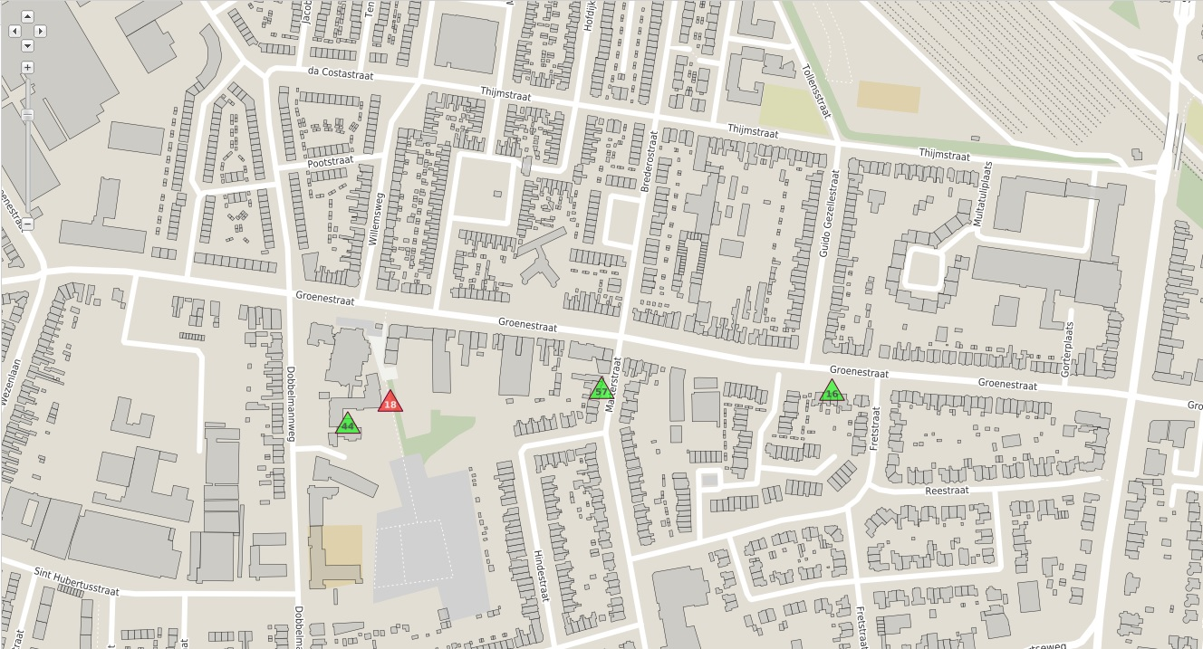
S44
S57
S16
GROENESTRAAT
Figure 1. Location of sensors 44, 57 and 16.

The first graph provides information about the noise levels during September. That will help us to have a sense about the traffic flow, about the patterns of the noise during a day and during the month.

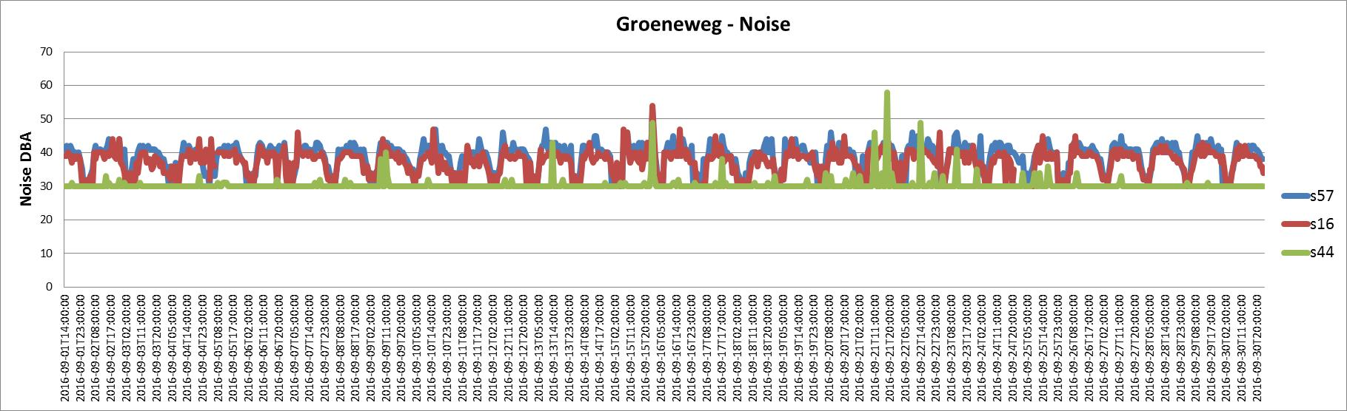
Groenestraat - Noise
Figure 2. Noise levels through September - sensors 57, 16 and 44.

A thing that stands out most from the graph is that S44 gives the lowest values of noise. This is maybe related with the fact that s44 is located in the back yard of the building, while the other two sensors are placed on the street side. An another remarkable thing is that sensors 57 and 16 give quite similar data and appear to have the same patterns every day during the month. So we can see similar traffic patterns. Both sensor 57 and sensor 16 show values that are above 40 dB(A) for longer periods of time during each day.

Analysis 2: Noise load of sensors 58, 28 and 26 during September

Sensors 58, 28, and 26 are located in different radius from the city centre, in the east area of Nijmegen. Sensor 58 is the closest sensor to city centre of these three sensors, while sensor 26 is the farthest one. The map below shows the location of these three sensors.
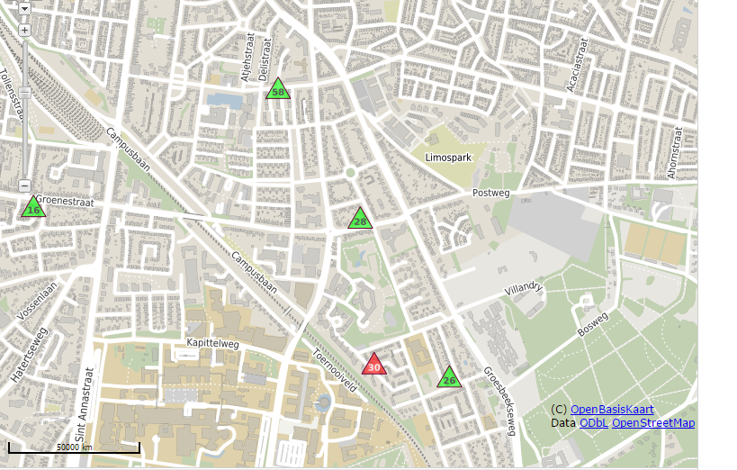
GROESBEEKSEWEG
S26
S28
S58
Figure 3. Location of sensors 58, 28 and 26.

The graph below illustrates the noise levels of sensors 58, 28 and 26 during the whole month. Unfortunately, scant data are provided about sensor 28.

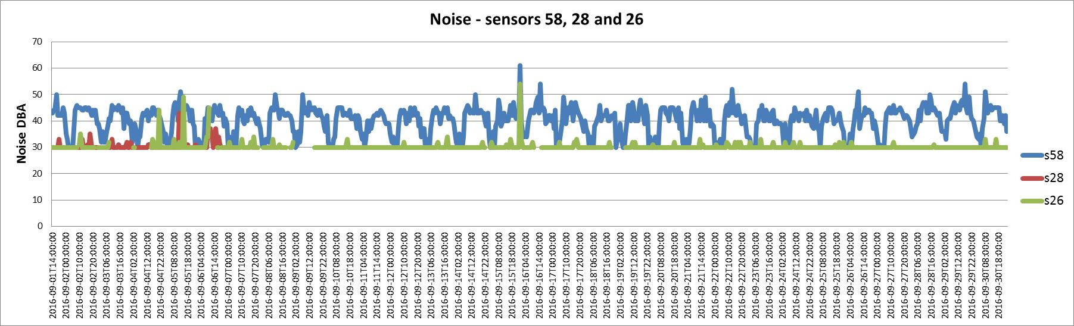
Figure 4. Noise levels through September - sensors 58, 28 and 26.

It is obvious from the graph that each sensor appears almost the same patterns every day. Sensor 26 gives more stable and lower values than sensor 58. Both sensors have their highest peak point on 16/9 at 24:00.
Interpretation and speculation about causes of differences between noise patterns shown by various sensor locations:
Reasons why sensor 58 may give higher noise load values as observed by sensor 58 in comparison to sensor 26 (or other sensors):
- The street of sensor 58, Argipelstraat, is an thoroughfare road through the city, which is heavily used by traffic. The noise pattern at sensor location 58 is similar to the noise pattern of sensor location 57 (Groenestraat), but with even higher noise value during the day, on average above 45 instead of above 40.
- The fact that sensor 26 gives more stable and lower dB(A) values than sensor 58 could be due to the fact that sensor 26 is further away from the city centre than sensor 58, and it is not located along a thoroughfare road through the city.

As we do not have information about relations between sources of noise and these measurements, we cannot say whether the observed noise patterns stem from either local traffic, or is influenced by distance from the city centre, or distance to other sources of noise, like the Groesbeekseweg or the railway.

Analysis 3: Noise load of sensors 46, 59, 24, 57, 44, 16, 31, 13 and 27

(See these sensor locations on map images at the end of this section)
The third graph provides information about the noise levels during the first ten days of September. We decided to pick up three sensors for each one of three different areas of the city and try to identify any similarities or differences between the areas or between the sensors.

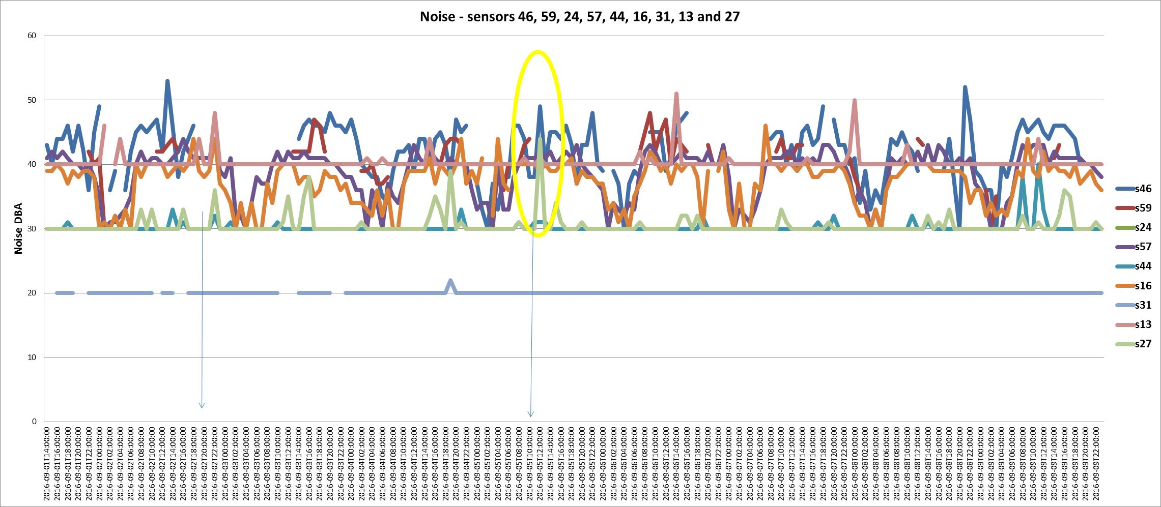
Figure 5. Noise levels through the first ten days of September - sensors 46, 59, 24, 57, 44, 16, 31, 13 and 27.
It is clear from the graph that Sensor 31 (S31) seem to be the most quiet sensor. S16 and S57 gives almost same values and appears similar patterns. S46 has also similar patterns with S16 and S57, but gives higher values than the other two sensors. Furthermore, S46 gives some peak points and seems to be the most noisy sensor.
The sensors that give the most stable data, with the smallest fluctuations are s31, s27, s13, s44. The fact that these noise patterns show ‘not-so-much fluctuations’ does not say that the average noise level is low, for instance, sensor 31 has a stable, but relatively high average noise value.
The first three sensors, s31, s27, and s13, are located at the west side of the town. Periodically, they present some peak points. Although, that points do not match each other.
S44 and S27 give similar values with each other, on average. An exception to this is the peak points of s27. On Friday 2/9/2016 from 20:00 to 22:00 s27, s16, and s13 appears the same "behaviour". On Monday 5/9/2016 from 10:00 to 12:00 s27 and s46 have a similar peak point.

S46
S59
S24
S57
S16
S44
S27
S13
S31
Figure 6. Location of sensors 46, 59, 24, 57, 44, 16, 31, 13 and 27.

Analysis 4: Looking at periods of relatively high noise patterns

We notice three sensor locations with longer episodes of relatively hight dB(A) values. They are located all in the city center (with sensor 46 just at the beginning of st Annastraat, close to Keizer Karelplein.) (See also the screendump of the Excelfile).
- Sensor 46, st Annastraat, close to Keizer Karelplein: short intervals with increased noise levels.
- Sensor 24, Bisschop Hamerstraat, very close to Keizer Karelplein: Long episodes of increased noise levels.
- Sensor 19, Grotestraat: almost continuously high noise values from half September onwards.

Thus, the most noisy areas of the month of September are all located in the city center.

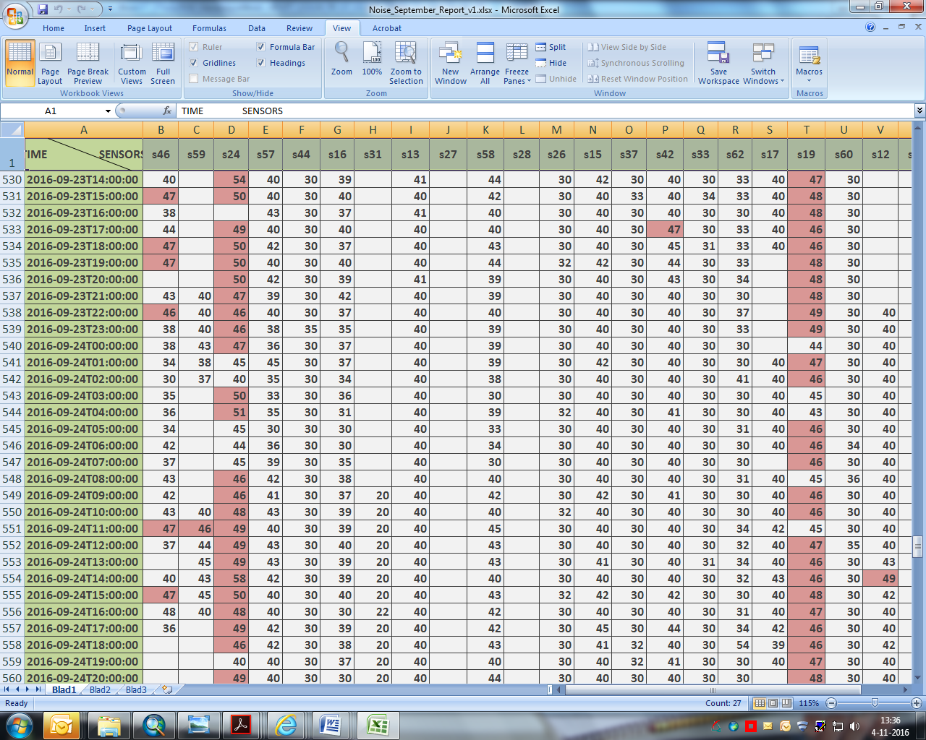
Figure 7. The noisiest sensors of September.

Conclusions:

Within the short period of time collecting all this data, we have one conclusion that we can draw directly from the data as expressed in the Excelfile:

The most noisy areas of the month of September are all located in the city center: the locations Bisschop Hamerstraat (sensor 24), st Annastraat (sensor 46) and Grotestraat (sensor 19).

The Excelfile could be analyzed in more detail. This data is provided to the citizens and projectteam members for purposes of more analysis and interpretation.

We hope the Excelfile gives a basis for making comparisons between locations and between time periods, for citizens and projectteam of Smart Emission. We hope you will find it also useful and we are looking forward to hearing your own observations and conclusions.

---
Annex 1: Map with sensors and sensor numbers.
Annex 2: Excel file with analysis data. (Excel document, file ‘Noise_September_Report.xls’)

Annex 1: Map with sensors and sensor numbers
