Use case analysis of sensors 46 and 57 in week 6 – 16 Sept (hot week / heatwave)

Made by: Msc. Zoi Katsamani

Date: 4-11-2016.

Including sensor stations: s46, s57, s12
Supervisor: dr.ir. Linda Carton.
Purpose:
This factsheet is meant for the projectteam and citizens of the smart emission project, for further interpretation and discussion.
This report just provides the data and data analysis of smart emission sensor data for the September week 6 – 16 September, a hot week. It focuses on the sensor data, it does not include data from other sources.
Disclaimer:
- During this use case analysis, in the meantime, the validation process was still being executed on the sensor-data 12 and 14 by data scientist Pieter Marsman.
- The reference stations s12 and s14 have problems during this period:
  - Reference sensor s14 was not measuring in this week, otherwise this sensor would have been included
  - Reference sensor s12 we have measurements only for the noise and CO2.

Short description of setup of this use case analysis
In September, during the days 6/9- 16/9 there was heatwave, or at least a ‘hot week’. Therefore, some questions that came to the surface need an answer:
- Do the data of sensors 57, 46 and 12 “describe” the heatwave?
- Are there any differences between the data provided from these three sensors?
- Do the CO2 levels differ between the days of the heatwave and the days 17th-27th July?
Consequently, we pick up the days 6/9- 16/9 and we are going to focus on these five indicators:
- Carbon Dioxide (CO2)
- Ozon (O3)
- Nitrogen Dioxide (NO2)
- Noise
- Temperature
Unfortunately, the NO2 data was not suitable and sufficient for a data analyses.

Analysis 1a: Emission Ozone and temperature
The first graph provides information about the ozone levels during the days 6th to 16th July. The sensor 12 did not give data for that days.
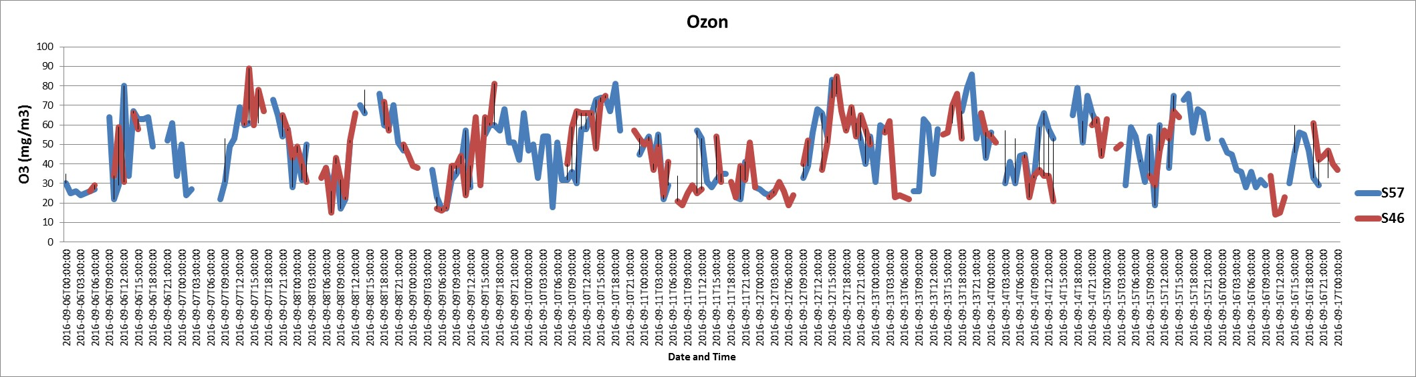
Figure 1. O3 levels through days 6/9/2016 – 16/9/2016 (sensors 57 and 46).
The most significant similarity about these two sensors is that they present the highest values of O3 during the hours 12:00-20:00 every day. The patterns are obvious at the graph above. Although, this phenomenon is not noticed on Sunday 11/9/2016. On this Sunday some peak points are noticed, but they do not give as high values as on the weekdays. An another noticeable thing is that the level of O3 changes a lot during the day and sensor 46 presents slightly bigger fluctuations than sensor 57.
The graph below illustrates the degrees Celsius during this week. Unfortunately, only sensors 57 and 46 provide us with data during that days.
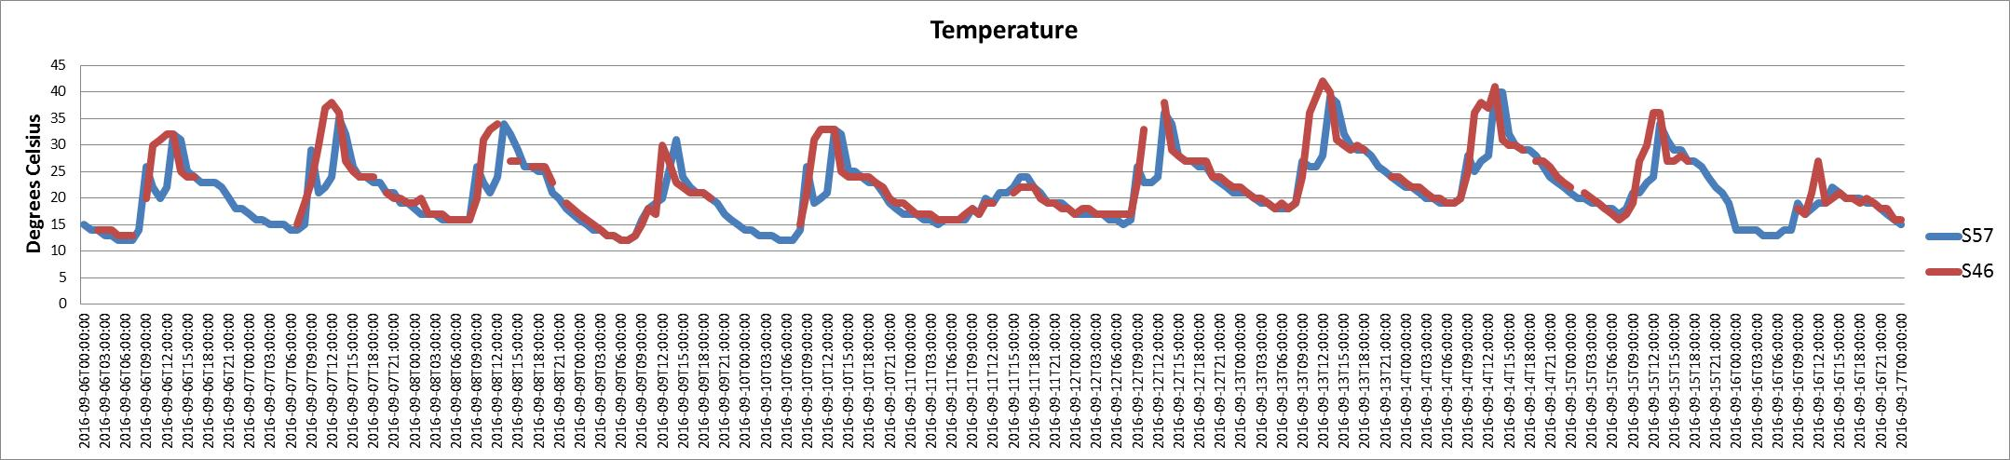
Figure 2. Temperature levels through days 6/9/2016 – 16/9/2016 (sensors 57 and 46).
It is clear from the graph that both sensors give quite similar data about the temperature. A thing that stands out most is that during a day, the temperature changes about 12/13 Celsius degrees, on average. A comparison between O3 levels and temperature shows that these two indicators follow almost the same pattern.

Analysis 1b: Noise load during 6th-16th July
The third graph provides information about the noise levels during these ten days of September. As you can easily notice, all of the sensors give data for this indicator.
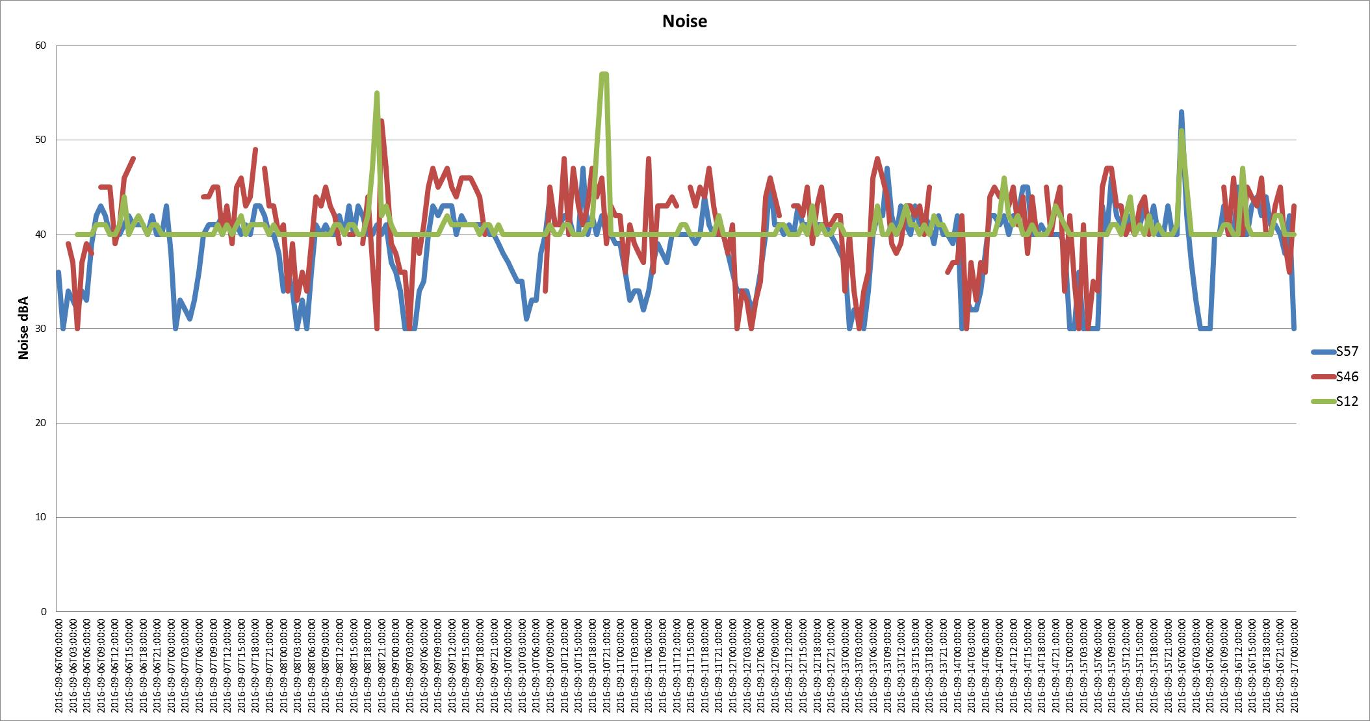
Figure 3. Noise levels through days 6/9/2016 – 16/9/2016 (sensors 57, 46, and 12).
It is clear from the graph that during this week sensor 57 has the lowest levels of noise in comparison with the other 2 sensors. The highest values of sensor 57 are similar with the lowest values of sensor 12. Sensor 46 presents the greatest fluctuations of the other 2 sensors. As can be seen clearly from the graph, sensor 12 presents some peak points at the below dates and times: Thursday 8/9/2016 18:00-23:00, Saturday 10/9/2016 19:00-22:00 and Friday 16/9/2016 23:00-02:00. This sensor is located at the city centre. The question then arises: "Are these peak points repeated every Thursday, Friday and Saturday of the month? Are they related with the hours that the shops are open on Thursdays or with the fact that people usually have a walk at the city centre on Fridays and Saturdays night?". We will come back with further information on this topic in the future.

Comparisons Vierdaagseweek with Heatwave week:
Comparing CO2 levels in week 29 (Vierdaagseweek) with week 36-37 (Heatwave):
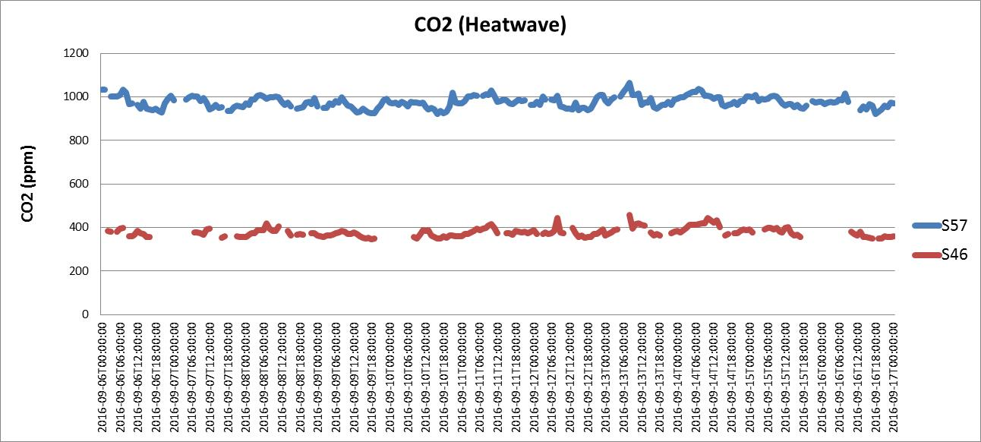
Figure 4. CO2 levels through days 6/9/2016 – 16/9/2016 (sensors 57 and 46).

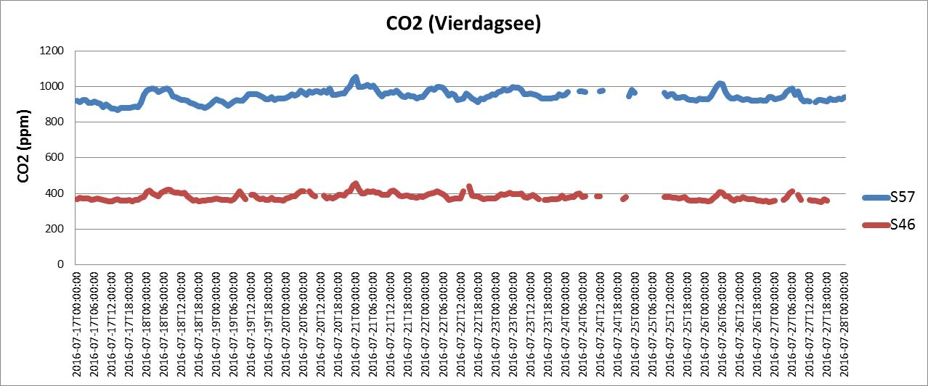
Figure 5. CO2 levels through days 17/7/2016 – 27/7/2016 (sensors 57 and 46).
It is obvious from the graphs that the CO2 levels in these two weeks are almost the same. A thing that stands out most is that sensor 46, that is located at Sint Annastraat presents lower levels of CO2 than sensor 57, that is located at Groenestraat. Nevertheless, both sensors appears peak points at the same days and hours. For example, some peak points are noticed in the early morning hours (02:00-08:00).

Contemporary conclusions

This factsheet is meant for the projectteam and citizens of the smart emission project, for further interpretation and discussion.
This report just provides the data and data analysis of smart emission sensor data for the September week 6 – 16 September, a hot week. It focuses on the sensor data, it does not include data from other sources. With this first look at the data from the sensors, we cannot make inferences about causes and effects or cause-effect relations.

Ozone emissions during Heatwave week (6/9/2016-16/9/2016):
An important outcome of this use case analysis is that ozone seems to follow a specific pattern during the days. Ozone increases during the hours 12:00-20:00 every day and it becomes almost double. Although, ozone seems to have an important decrease on Sundays. A data analysis of ozone layers during other weeks of the year, will give a clear view of these “ozone patterns” and of the ozone layers on Sundays.

Noise pattern during Heatwave week (6/9/2016-16/9/2016):
A noticeable thing about noise in this data analysis is that some high peak points are noticed during Thursday, Friday and Saturday night. A comparison between other Thursdays, Fridays and Saturdays of the year could shed more light about the relation between those data and use of the city by its residents.
Speculation about possible relations between city use, citizen behavior and sensor observations:
For example, relate shops opening hours, and behavior of citizens living in and around the city to come to the city center for going out, shopping or recreational purposes (eating out, cinema, culture, etc) on Thursdays, Fridays and Saturdays. The increased Ozone on Thursday, Friday and Saturday night might represent this travel behavior, we could speculate that the increased Ozone may be caused by residents (or people from outside the city) coming to the city center by car. We do not know what causes the high peak points in noise during Thursday, Friday and Saturday night, but we could speculate this also may have something to do with the ‘vibrant city center at Thursday, Friday and Saturday night’.
Suggestion for further study: we could possibly ask citizens and do analysis with other sources of information, like traffic data and parking data, to find out more about this pattern, if citizens/researchers/specialists feel a need to analyze this case more in depth.

Carbon Dioxide pattern during Heatwave week (6/9/2016-16/9/2016):
The levels of CO2 seem to be stable during the days. This phenomenon is noticed both in the Vierdaagse week and in the Heatwave week. The values have a little divergence during a day and some peak points are noticed. Another remarkable outcome is that sensor 46 (located at Sint Annastraat) gives quite lower values of this indicator than sensor 57 (located at Groenestraat), for both periods.
Suggestion CO2 analysis:
The gas CO2, according to air quality specialists, behaves ‘like a heavy blanket’; it is not as volatile as other gases like O3 or NO2. We see that the CO2 level does not change in time, at the observed sensor locations. But the average CO2 level does show significant differences between sensor locations.
It could be worthwhile to make a spatial interpolation of CO2 levels across the city, to find out if we can indeed visualize this ‘heavy blanket’ and see how this blanket is “drapped over the city”, with its spatial variations.

Closing

This data report has been written for citizens and projectteam of the Smart Emission project. It is up to them to interpret the sensor observations. This report is made as an aid in tracing some weeks and some sensors, to present sensor data in a compressed way for a particular question (use case), with particular focus in time and space.
We hope these current sensor data analysis gives more food for thought.

