Use case analysis of sensors 46, 57, 12 and 14 in week 17 – 27 July ’16

Subject: analysis Vierdaagse festival week

Data analysis made by: Msc. Zoi Katsamani, Radboud University, Institute for Management Research.

Assignment supervised by: dr.ir. Linda Carton, Radboud University, Institute for Management Research.

Date: 3-10-2016.

Including sensor stations: s46, s57, s12, s14

Disclaimer:

During this use case analysis, in the meantime, the calibration process of sensors relative to national measurement stations is still in execution in this period, executed on the sensor-data of sensors s12 and s14, executed by data scientist Pieter Marsman.

The reference stations s12 and s14 have some (connection) disturbances during this period:

Reference sensor s14 was not measuring in this week, otherwise this sensor would have been included

Reference sensor s12 we have measurements only for the noise and CO2.

Short description of setup of this use case analysis
The goal of this use case analysis is twofold:
- to identify the differences between sensors 46 (address), 57(address), 12 (address) and 14 (address) during the days 17/7-27/7 and
- to explore whether we can identify the Vierdaagse festival in the data provided.
The Vierdaagse festival took place in the days 19-22 July. Consequently, we pick up the days 17/7- 27/7, as we need some days before and after the festival to make the comparison. We are going to focus on these five indicators:
- Carbon Dioxide (CO2)
- Ozon (O3)
- Nitrogen Dioxide (NO2)
- Noise
- Temperature
Although, at this report you will get informed about Ozone, Temperature and Noise, as these three indicators provide us with the most outstanding results.

Analysis 1a: Emission Ozone and temperature

The first graph provides information about the ozone levels during the days 17th to 27th July. The sensors 12 and 14 did not give data for that days.
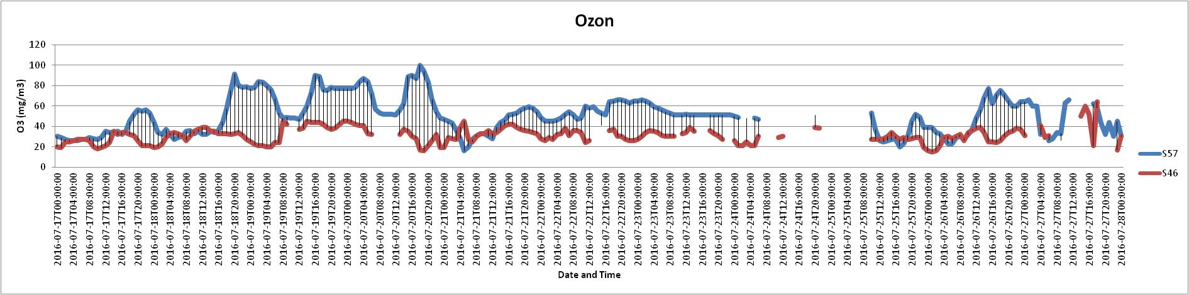
Figure 1. O3 levels through days 17/7/2016 – 27/7/2016 (sensors 57 and 46).
The thing that stands out most is that sensor 57 presents higher levels of O3 than sensor 46. In addition, an another remarkable thing is that the highest values of O3 appears during the evening.
The graph below illustrates the degrees Celsius during this week. Unfortunately, only sensors 57 and 46 provide us with data during that days.
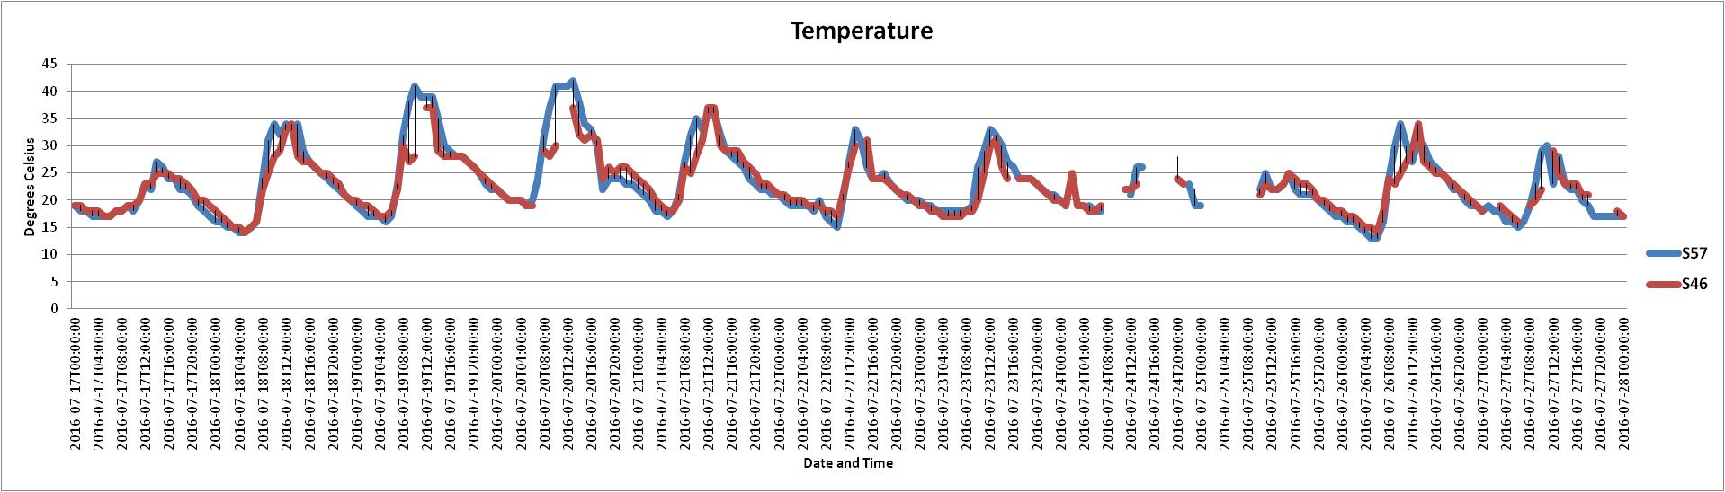Figure 2. Temperature levels through days 17/7/2016 – 27/7/2016 (sensors 57 and 46).
It is clear from the graph that both sensors give quite similar data about the temperature. A thing that stands out most is that during a day, the temperature changes from 8 degrees Celsius to 13 degrees Celsius, on average.

Analysis 1b: Noise load during the Vierdaagse festival

The third graph provides information about the noise levels during these ten days of July. As you can easily notice, all of the sensors give data for this indicator!

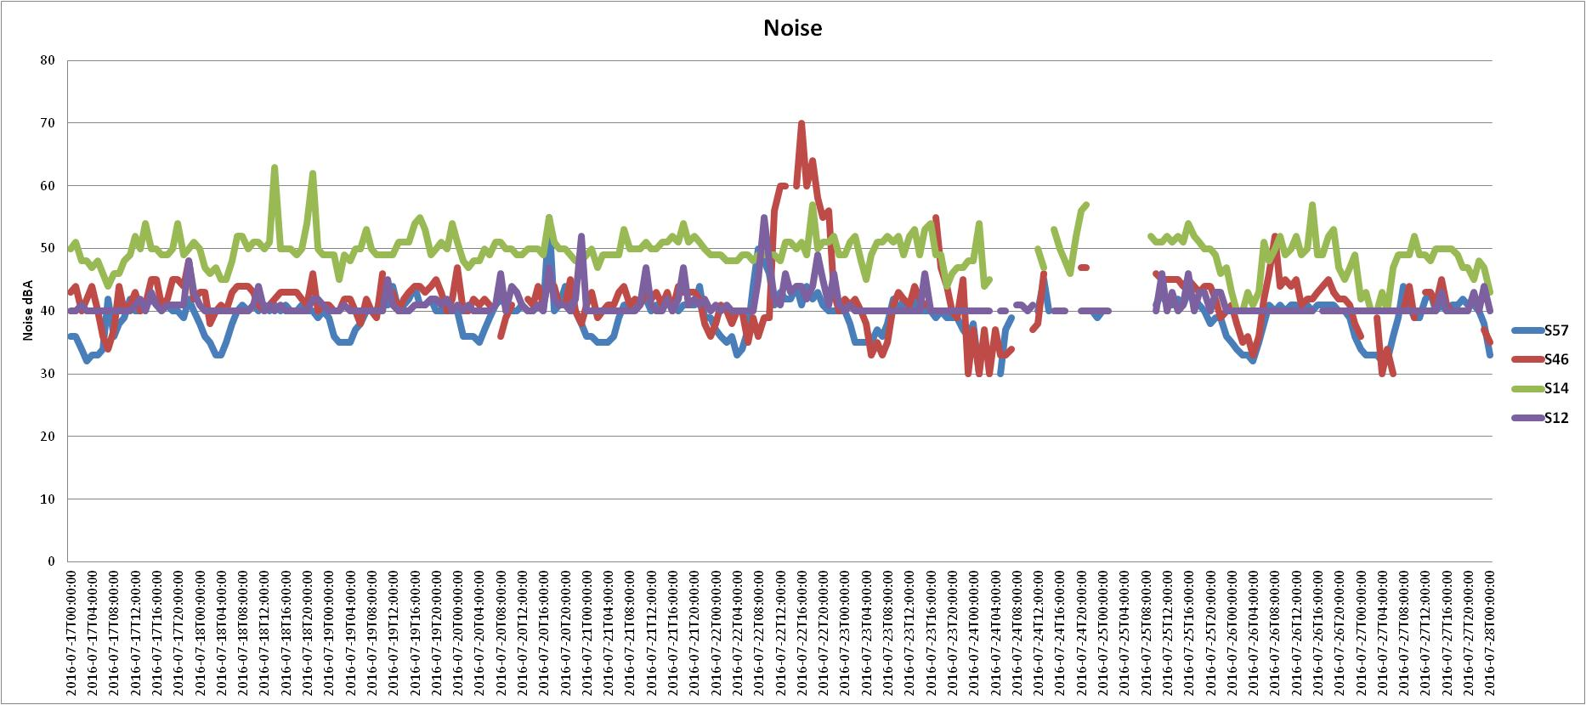
Figure 3. Noise levels through days 17/7/2016 – 27/7/2016 (sensors 57, 46, 14 and 12).

It is clear from the graph that sensor 14 presents the highest values of noise during these days, while sensors 57 and 12 present the lowest ones. A remarkable thing is that the noise level of sensor 46 on 22/7/2016 and from 11:00 till 22:00 is constantly on or over 55 db(A), with a peak in the hour of 16:00-17:00, with an average db(A) value of 70.

“Vierdaagse in the data provided”
S46
time (22-7-2016) | noise (dBA)
0:00:00 | 38
1:00:00 | 41
2:00:00 | 40
3:00:00 | 38
4:00:00 | 40
5:00:00 | 40
6:00:00 | 35
7:00:00 | 39
8:00:00 | 36
9:00:00 | 39
10:00:00  The table shows clearly the dB(A) levels of sensor 46 during the day of 22nd July. The highest values of the day are marked with red colour and are apparently related with Vierdaagse festival. | 39
11:00:00 | 56
12:00:00 | 60
13:00:00 | 60
14:00:00
15:00:00 | 60
16:00:00 | 70
17:00:00 | 60
18:00:00 | 64
19:00:00 | 58
20:00:00 | 55
21:00:00 | 56
22:00:00 | 43
23:00:00 | 40
Figure 4. Db(A) values for sensor 46 during the day July 22nd , during the Vierdaagse festival.

Comparisons:

Comparing O3 levels in week 29 (Vierdaagseweek) with week 36-37:
Figure 5. O3 levels through days 17/7/2016 – 27/7/2016 (sensors 57 and 46).
The green circle area at the graph above let us make the conclusion that Vierdaagse intocht, walking into the city, could mean less traffic in the Groenestraat and Annastraat, where sensor 57 and 46 are based. Compared to week 36-37 in September, as the graph below shows, there are peak levels of O3 every day.
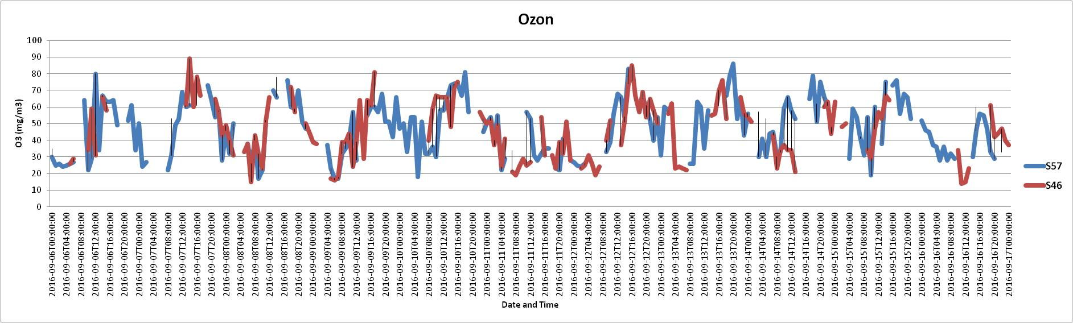
Figure 6. O3 levels through days 06/09/2016 – 17/9/2016 (sensors 57 and 46).
In this ‘regular week’, the only day that lower levels of O3 are noticed is on Sunday. If this is the case in regular weeks is food for further research.

Contemporary conclusions

Ozone emissions during Nijmeegse Vierdaagse week:
From these analyses on the indicative data of the smart emission sensors, it seems that in the Vierdaagse week, the pattern of Ozone and Noise show a different pattern than in a regular week: with emission of ozone lower than normal on the days 21,22 and 23 of July, which is Thursday, Friday and Saturday in the Vierdaagse week. Additional analysis of traffic on these days, and citymap of closed roads and additional information about the route of the Vierdaagse and the stream of walkers in the city, could shed more light on the use of the city and the deviant pattern of emissions due to events such as this urban festival of the Nijmeegse Vierdaagse.
Noise pattern during the Nijmeegse Vierdaagse week:
On the day of the Vierdaagse festival, on Friday 22 of July, the sensor s46 that hung close to one of the festival music stages, along the st Annastraat, showed an increased noise load from 11:00 till 22:00 hours, above 50 dB(A) for the hour-average dB(A) value, with a peak of 70 db(A) on average in the hour of 16:00 – 17:00h.
Remarks about visualization and analysis:
It seems for now that visualization of a week or 10-day series, with a few sensors combined in one graph, offers us an effective presentation for doing analysis. While 3-dimensional visualizations and GIS-visualizations can possibly add to the quality of visualizing, the current presentation with emphasis on analyzing time (while knowing where sensors are located based on their sensor-ID) seems good enough for the current objective of finding differences in patterns and levels in time between sensors and between days and weeks.
The understanding of these patterns, and the combination with other sources of information such as the use of the city and traffic on weekdays and in case of special events, could enrich the analysis, and contextualize the data for purpose of understanding what is happening in the city in terms of air quality and noise across time and space. For the purpose of understanding relations between events, traffic patterns, behavior of masses of people coming into and going out of the city, and production of ‘externalities’ like emissions and noise, additional information and analysis (or urban modeling) seems fruitful for enhanced understanding of the cities’ dynamics.
Conclusion:
The smart emission sensor network seems to be able to track differences in space and time in terms of ozone emissions and noise load levels during ‘events’ in the city center, in this case the Vierdaagse festival. Tracing differences in a fine-grained pattern in the city, an objective of the Smart Emission project, seems to be successful.
The traced patterns of ozone emissions and noise levels signify that externalities in terms of emissions and noise can be measured with a citizen-sensor-network, and that differences in space and time can be observed and traced with this method.
Information about the calibration of the sensordata, executed by data scientist Pieter Marsman and information advisor Paul Geurts (gemeente Nijmegen), should give more certainty about the accuracy of the sensor data. The current data pattern does seem to give significant changes over time. The differences in the indicators ozone patterns and noise load of sensors in the city center, compared between a ‘normal week/normal day’ and the Vierdaagse weekly pattern, seem significant.
Comparison with sensor data of many weeks (and more sensors spread out across the city) should shed more light on “normal weekly patterns” of the city center, and “deviating days or weeks” due to events.
---
Annex 1: Map with sensors and sensor numbers.
Annex 2: Excel file with analysis data. (Excel document, file ‘CaseAnalysis_17-27 July_ZK_LC.xls’)

Annex 1: Map with sensors and sensor numbers
